**Steps to download and upload Key (ID) Mapping Files from S4 Hana (CFIN)**

Step1 Login to SAP S4 CFIN system suing SAP GUI.

Step2 Run TR code **fins_cfin_map_manage** to get into Mapping window

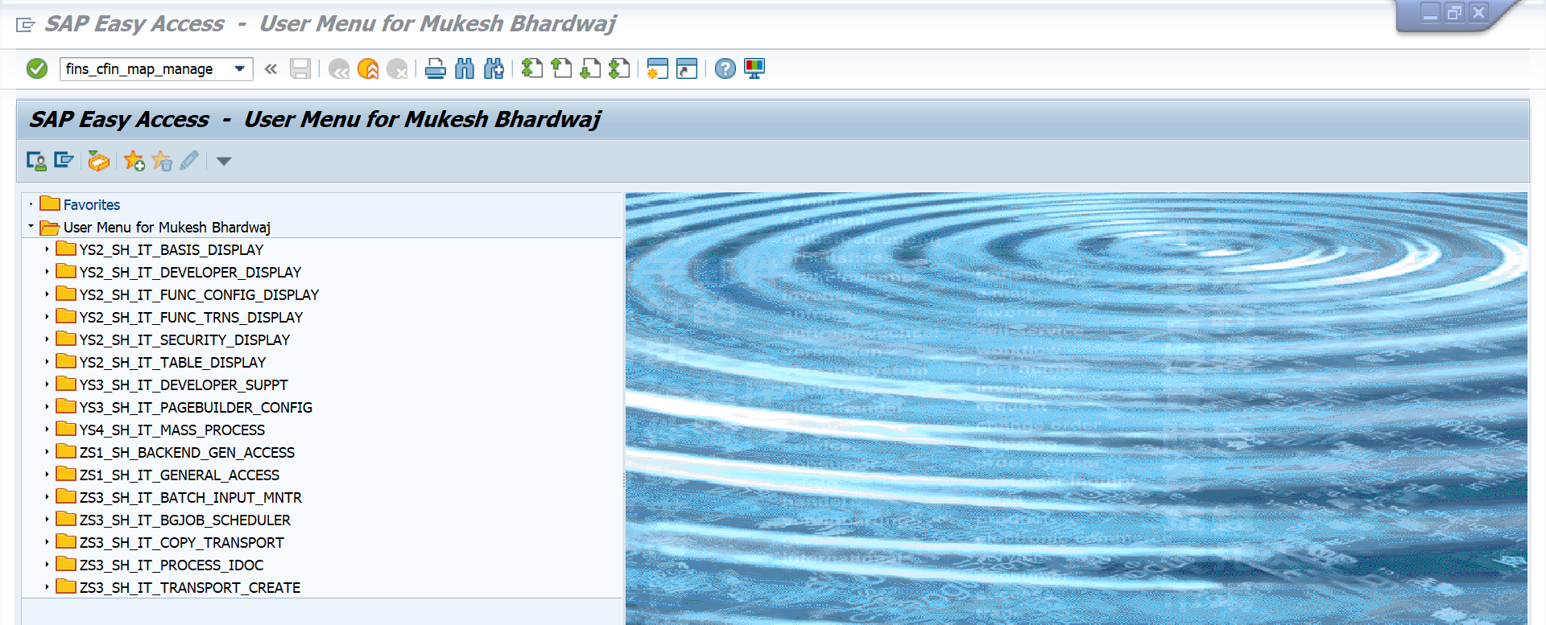

Step3 Select the required Data Object for which mapping is to be done

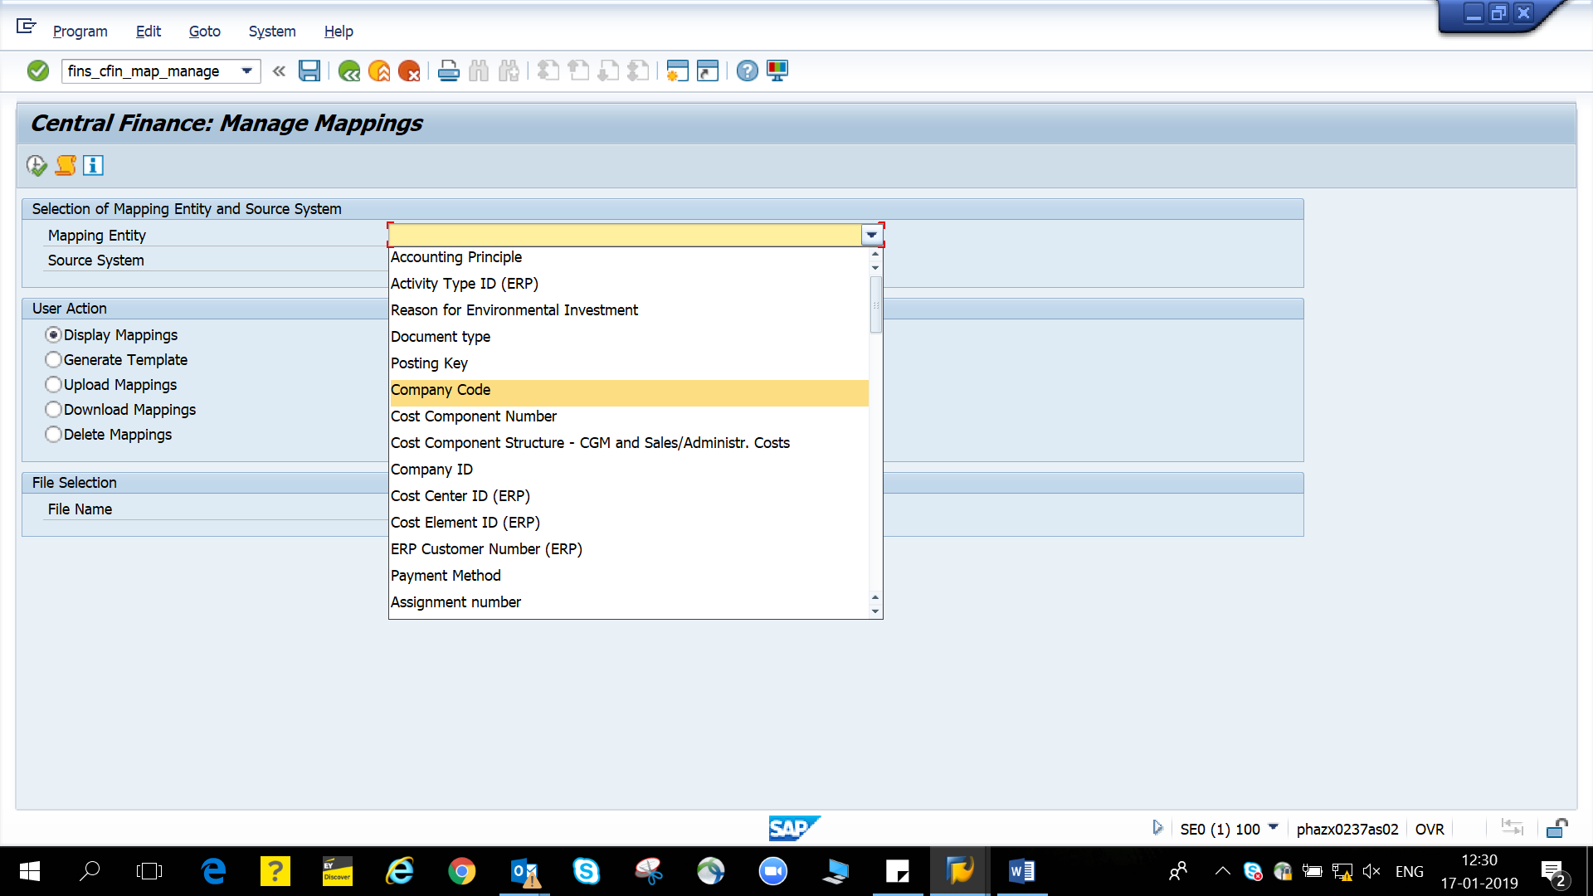

Step4 You can either download a empty template or download a file with the existing mapping already residing in the system.

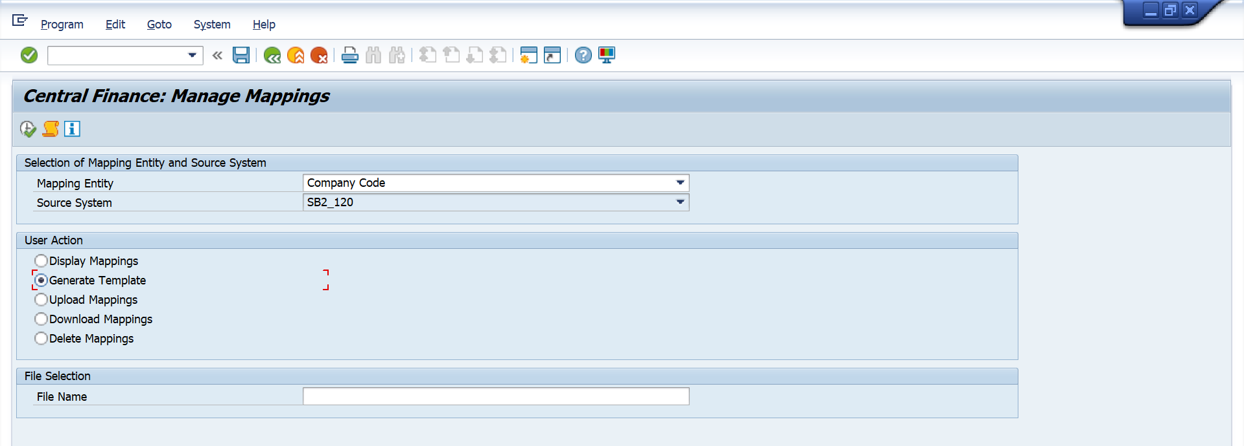

Step5 Download the file in csv format and select the local folder location and click execute.

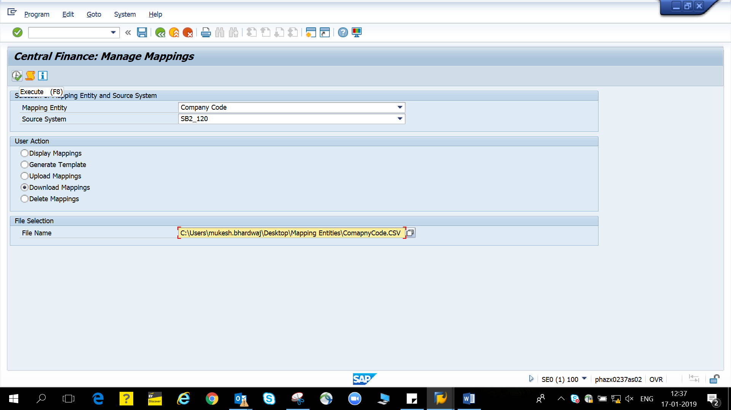

Step 6 The file would be generated and can be filled with the required mapping.

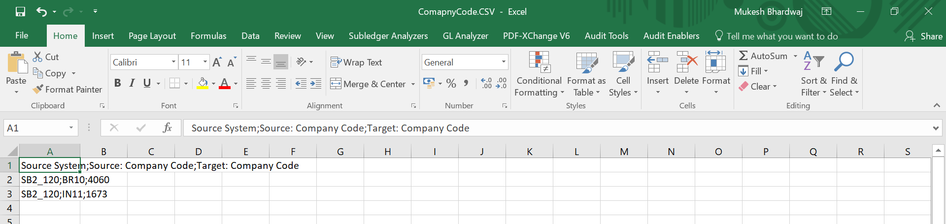

Step 7 the file can be filled with required mapping of the code and uploaded back so that S4 can be refreshed with new code mapping.

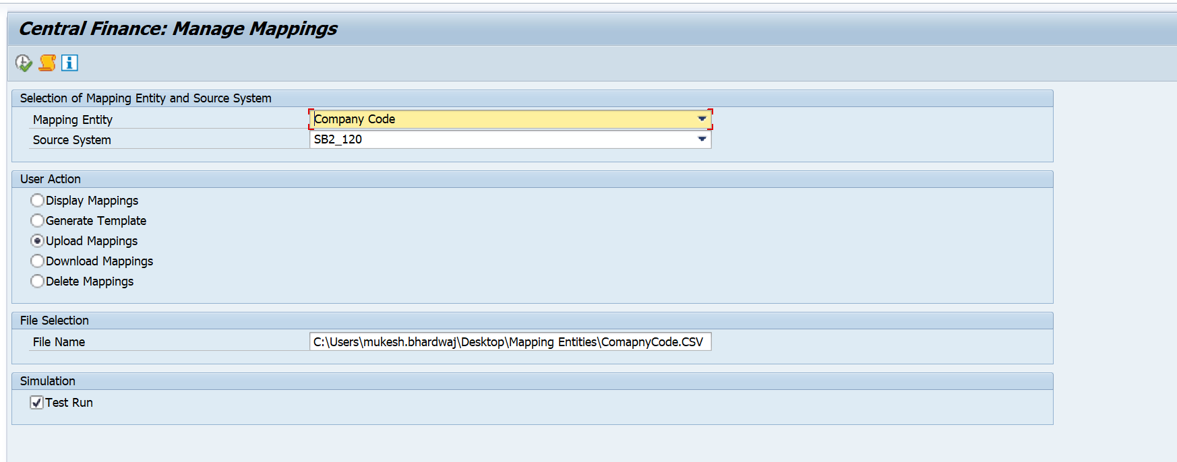

**SAP Notes for Mass Upload of Mappings:**

Central Finance: Manage Mappings

**Use**

With business mapping in Central Finance, you define a relationship between an identifier or code used in a source system and one used in the Central Finance system. This is necessary because for the same mapping entity, such as cost center or general ledger account, different identifiers or codes may be used in the systems. For example, in the source system a customer may have the ID 28900, whereas in the Central Finance system, the same customer has the ID 13700.

You can use this mapping tool to manage the mappings for master data and customizing objects that are supported in Central Finance.

You can use the report before going live with the Central Finance system, as well as after that, if you have to add new mappings. The system uses the mappings during the initial load of data from your source systems and when transferring transactional data to Central Finance, that is, when new postings are made in the source system.

**Note**

You **cannot** mass upload, download, display or delete mappings of mapping entities for **cost objects** with this mapping tool.

**Integration**

For single mappings you can still use the following *Customizing* activities (transaction **SPRO** *-> SAP Reference IMG*) in *Central Finance*:

* [**Create and Edit Key Mapping**](sapevent:DOCU_LINK\DS:SIMG.DOCU_MDG_KM_MAINTAIN) (under *Financial Accounting (New) -> Central Finance -> Mapping -> Define Key Mapping (ID Mapping)*
* [**Maintain Value Mapping**](sapevent:DOCU_LINK\DS:SIMG.DOCU_FINS_CFIN_VM_01) (under *Financial Accounting (New) -> Central Finance -> Mapping -> Define Value Mapping (Code Mapping)*

**Requirements**

You have the authorization for the transaction **FINS_CFIN_MAP_MANAGE**.

**Features**

* You can display mappings for key mapping (ID mapping) entities, as well as for value mapping (code mapping) entities.
* You can use templates that allow you to easily prepare the mapping values in a CSV file error-free for key mapping entities and value mapping entities.
* You can do a mass upload for key mappings (ID mappings) and value mappings (code mappings) from a CSV file. For this, you need to select a mapping entity and source system.

**Note**

Uploading a CSV file is language-dependent. If a user prepares a CSV file in a system being logged on in one language, and another user tries to upload this already prepared CSV file in the same system being logged on in a different language, the CSV file **cannot** be uploaded to the system.

* You can do a mass download for key mapping (ID mapping) entities, as well as value mapping (code mapping) entities.
* You can do a mass deletion for key mappings (ID mappings) and value mappings (code mappings). You have two options for deleting existing mappings:
  + If you want to delete **all mappings for a mapping entity**, you select the mapping entity and source system, tick the *Delete Mappings* action and execute the report.

You can use this option for deleting key mappings only.

* + If you want to delete **certain mappings for a mapping entity**, you prepare a CSV file with the entries to be deleted. On the selection screen, you select a mapping entity and source system, tick the *Delete Mappings* action, enter a CSV file with its path and execute the report.
* You can execute a test run for uploading and deleting mappings.

This allows you to see how it would look like without already having to upload the mappings to the *Master Data Governance* (MDG) tables or delete them from the MDG tables.

* After upload and delete a log is displayed and you can download it. Logs are also saved in the system and you can always open a log previously created by clicking the *Display Log* icon. A list of logs is displayed and you can choose a log from the list.

If an error is found, the corresponding mapping is ignored and it is neither uploaded to the *Central Finance* system, nor deleted from the *Central Finance* system.

* If you are uploading or deleting value mappings in an update run (**not** in the test run) and depending on the system settings, you additionally have to enter a customizing request or task.

As in value mappings, the objects you are mapping from the source to the *Central Finance* system are customizing objects, the transport request ensures that the mapping of customizing and the related customizing object can be distributed consistently to the system landscape according to the system settings.

* The report checks syntax and format of the mapping entities allowed in the CSV file. For example, the report checks the structure, the correct columns and labels, the number of columns, the field length and mandatory mapping IDs.
* The report checks, whether context fields are identical for the source and the *Central Finance* system. Context fields are, for example, the country codes for the payment methods. Context fields can be left empty for key mappings, but must be filled for value mappings.
* The report checks within the CSV file identical rows and 1:n mappings (mappings that assign one value in the source system to multiple values in the *Central Finance* system). In this case an error message is displayed in the log.
* The report checks, whether the mapping already exists in the *Central Finance* system. It also checks, whether by uploading a CSV file there would be 1:n mappings in the *Central Finance* system. This is **not** allowed.
* The report checks whether a mapping value in the source or *Central Finance* system exists. You can configure the respective warning or error message by calling transaction OBA5 for the application area FINS_CFIN_MAPPING.

**Selection**

Before running the report, you specify parameters, for which you want to execute the mapping action:

* Mapping Entity

This is one of the mapping entities supported in *Central Finance* and defined in Customizing of *Central Finance* under *Financial Accounting -> Central Finance -> Mapping ->* [**Define Mapping Actions for Mapping Entities**](sapevent:DOCU_LINK\DS:SIMG.VC_FINS_CFIN_MAP).

* Source System

This is one of the business systems defined in Customizing of *Central Finance* under *Financial Accounting -> Central Finance -> Mapping ->* [**Define Technical Settings for Business Systems**](sapevent:DOCU_LINK\DS:SIMG.DOCU_FINS_CFIN_TS_BS).

* File Name

You enter a directory and file name with extension CSV.

**Output**

Depending on the action you chose, the system does the following:

* With *Display Mappings*, the system shows you a list of mappings.
* With *Generate Template*, the system generates a CSV file template that you can use to enter your mappings.
* With *Upload Mappings*, the system uploads the mappings, where no issues can be found, to the *Central Finance* system. The system checks the correctness of the mapping rows and lists issues according to a category in a log. In the log, you can easily see what kind of issues occurred.
* With *Download Mappings*, the system downloads mappings from the *Central Finance* system.
* With *Delete Mappings*, the system deletes the mappings that you entered in a CSV file from the *Central Finance* system. If you don'tenter any CSV file, the system deletes all mappings for the selected mapping entity and source system. You can only use this option for key mappings.

**Activities**

To access this report call the transaction **FINS_CFIN_MAP_MANAGE**. This transaction is also part of the user role SAP_SFIN_CFIN_ADMIN which can be assigned to your user.